The Arnold roofing concept: encompassing an innovative trio
Arno Arnold presents the Arnold roofing concept, a type of “modular” roof covering kit which is available for use as a standalone roof, a combined roof and rear wall, or as a retrofitted roof. While roof coverings and crane loading often leave constructors with an impossible task of “squaring the circle”, Arnold offers a range of helpful solutions.

For the most part, the trend nowadays is moving towards optional roof coverings which can be seamlessly connected to a pre-existing rear wall as required. Among the advantages: chips, coolant and vapors can be controlled at their source, staff is protected and sound levels are reduced.
This is why machine designers often choose to seal off their machine at the top by applying a roof covering to prevent dirt, liquid and chips from escaping the processing area. The key question is, how should the roof be designed?
If it needs to withstand hot or sharp chips, Arno Arnold recommends a roof covering with a built-in rear wall, using a product with telescopic sheets, e.g. Wings, Duplet or Strapano.

Given the importance of external access to machine tools, a roof covering may prove a hindrance when the time comes to replace workpieces, or when using various handling devices with larger and heavier units or with interlinked and fully automated production lines.
However, roof covering and crane loading need not be mutually exclusive. Arnold recently launched three innovative solutions in this very field.

1. Innovation => Locking system.
If the machine roof is too high to push the Y-bellows back manually, the locking system establishes a connection between the moving columns and the end frames. If the moving columns travel all the way to the front, it tilts the front end frames backward in the same motion – including the guide rods, which would otherwise form the front supporting surface of the roof and become a pinch point when changing workpieces. This allows a connecting link to be turned through 90° from the front, whereby both slide bars perform either an outward or inward stroke.
This mechanism is attached out of sight behind the front end frame, leaving only the square bore visible for the key to be applied. When pressed together, the rear end frame is seamlessly connected to the front end frame.
The same stroke also locks the front end frame in the front end position to ensure normal operation.

- Innovation => Moover, the swivel-mounted roof.
Thomas Kreutzer, Design and Development Manager at Arno Arnold: “Our new Moover protective cover is the solution which proves that optimal roof covering and crane loading without additional space requirements need not be mutually exclusive. During normal operation, Moover functions reliably as a top or rear protective cover for the workspace. The innovative element is the flexible but tight corner joint between the vertical and horizontal cover. Combining this with a guided connection between the Y-bellows and the moving columns allows an opening angle which frees up the entire work space. The complete system can also be tailored to individual customer requirements, based on the configuration of the machine.” The drive type can be selected to meet individual machine manufacturer requirements, from fully automatic to manual.

Benefit
Crane loading is possible with a roof covering.

- Innovation => Transparent roof
If the covering is not directly exposed to flying chips, Arnold recommends using a flexible roof covering protection solution from the Classic bellows series. Crane loading is possible using a movable guiding system.
The highly practical new model involves processing a new material – and as a “bellows inventor,” Arno Arnold possess unrivaled in-depth expertise in this area. Leveraging close collaboration with material manufacturers and comprehensive pure research in our in-house technology center, Arnold has developed a unique new roof covering material. It is transparent, which optimizes interior lighting by allowing light to pass through the covering and illuminate the processing area from outside.

Benefit:
The covering allows existing exterior light into the machine processing area, helping to reduce the cost of interior lighting which would otherwise be needed.

Picture 1:
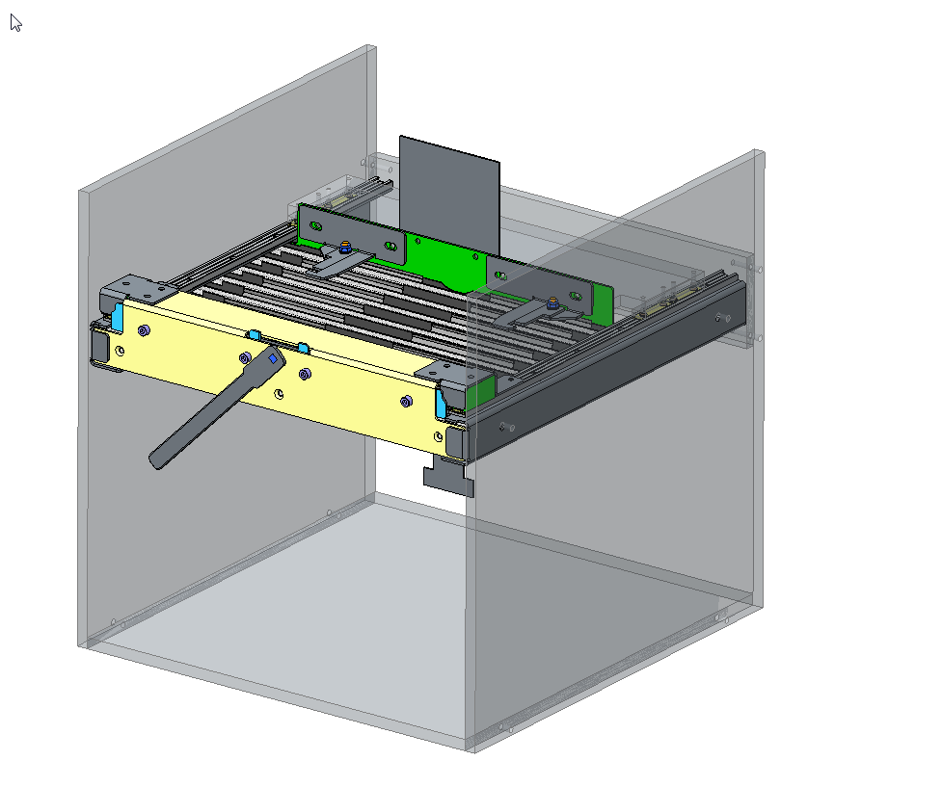

The Y-bellow can be manually released from a closed position using a locking lever and automatically moved backward with the moving columns, which frees up overhead space to allow workpieces to be changed.

Picture 2:
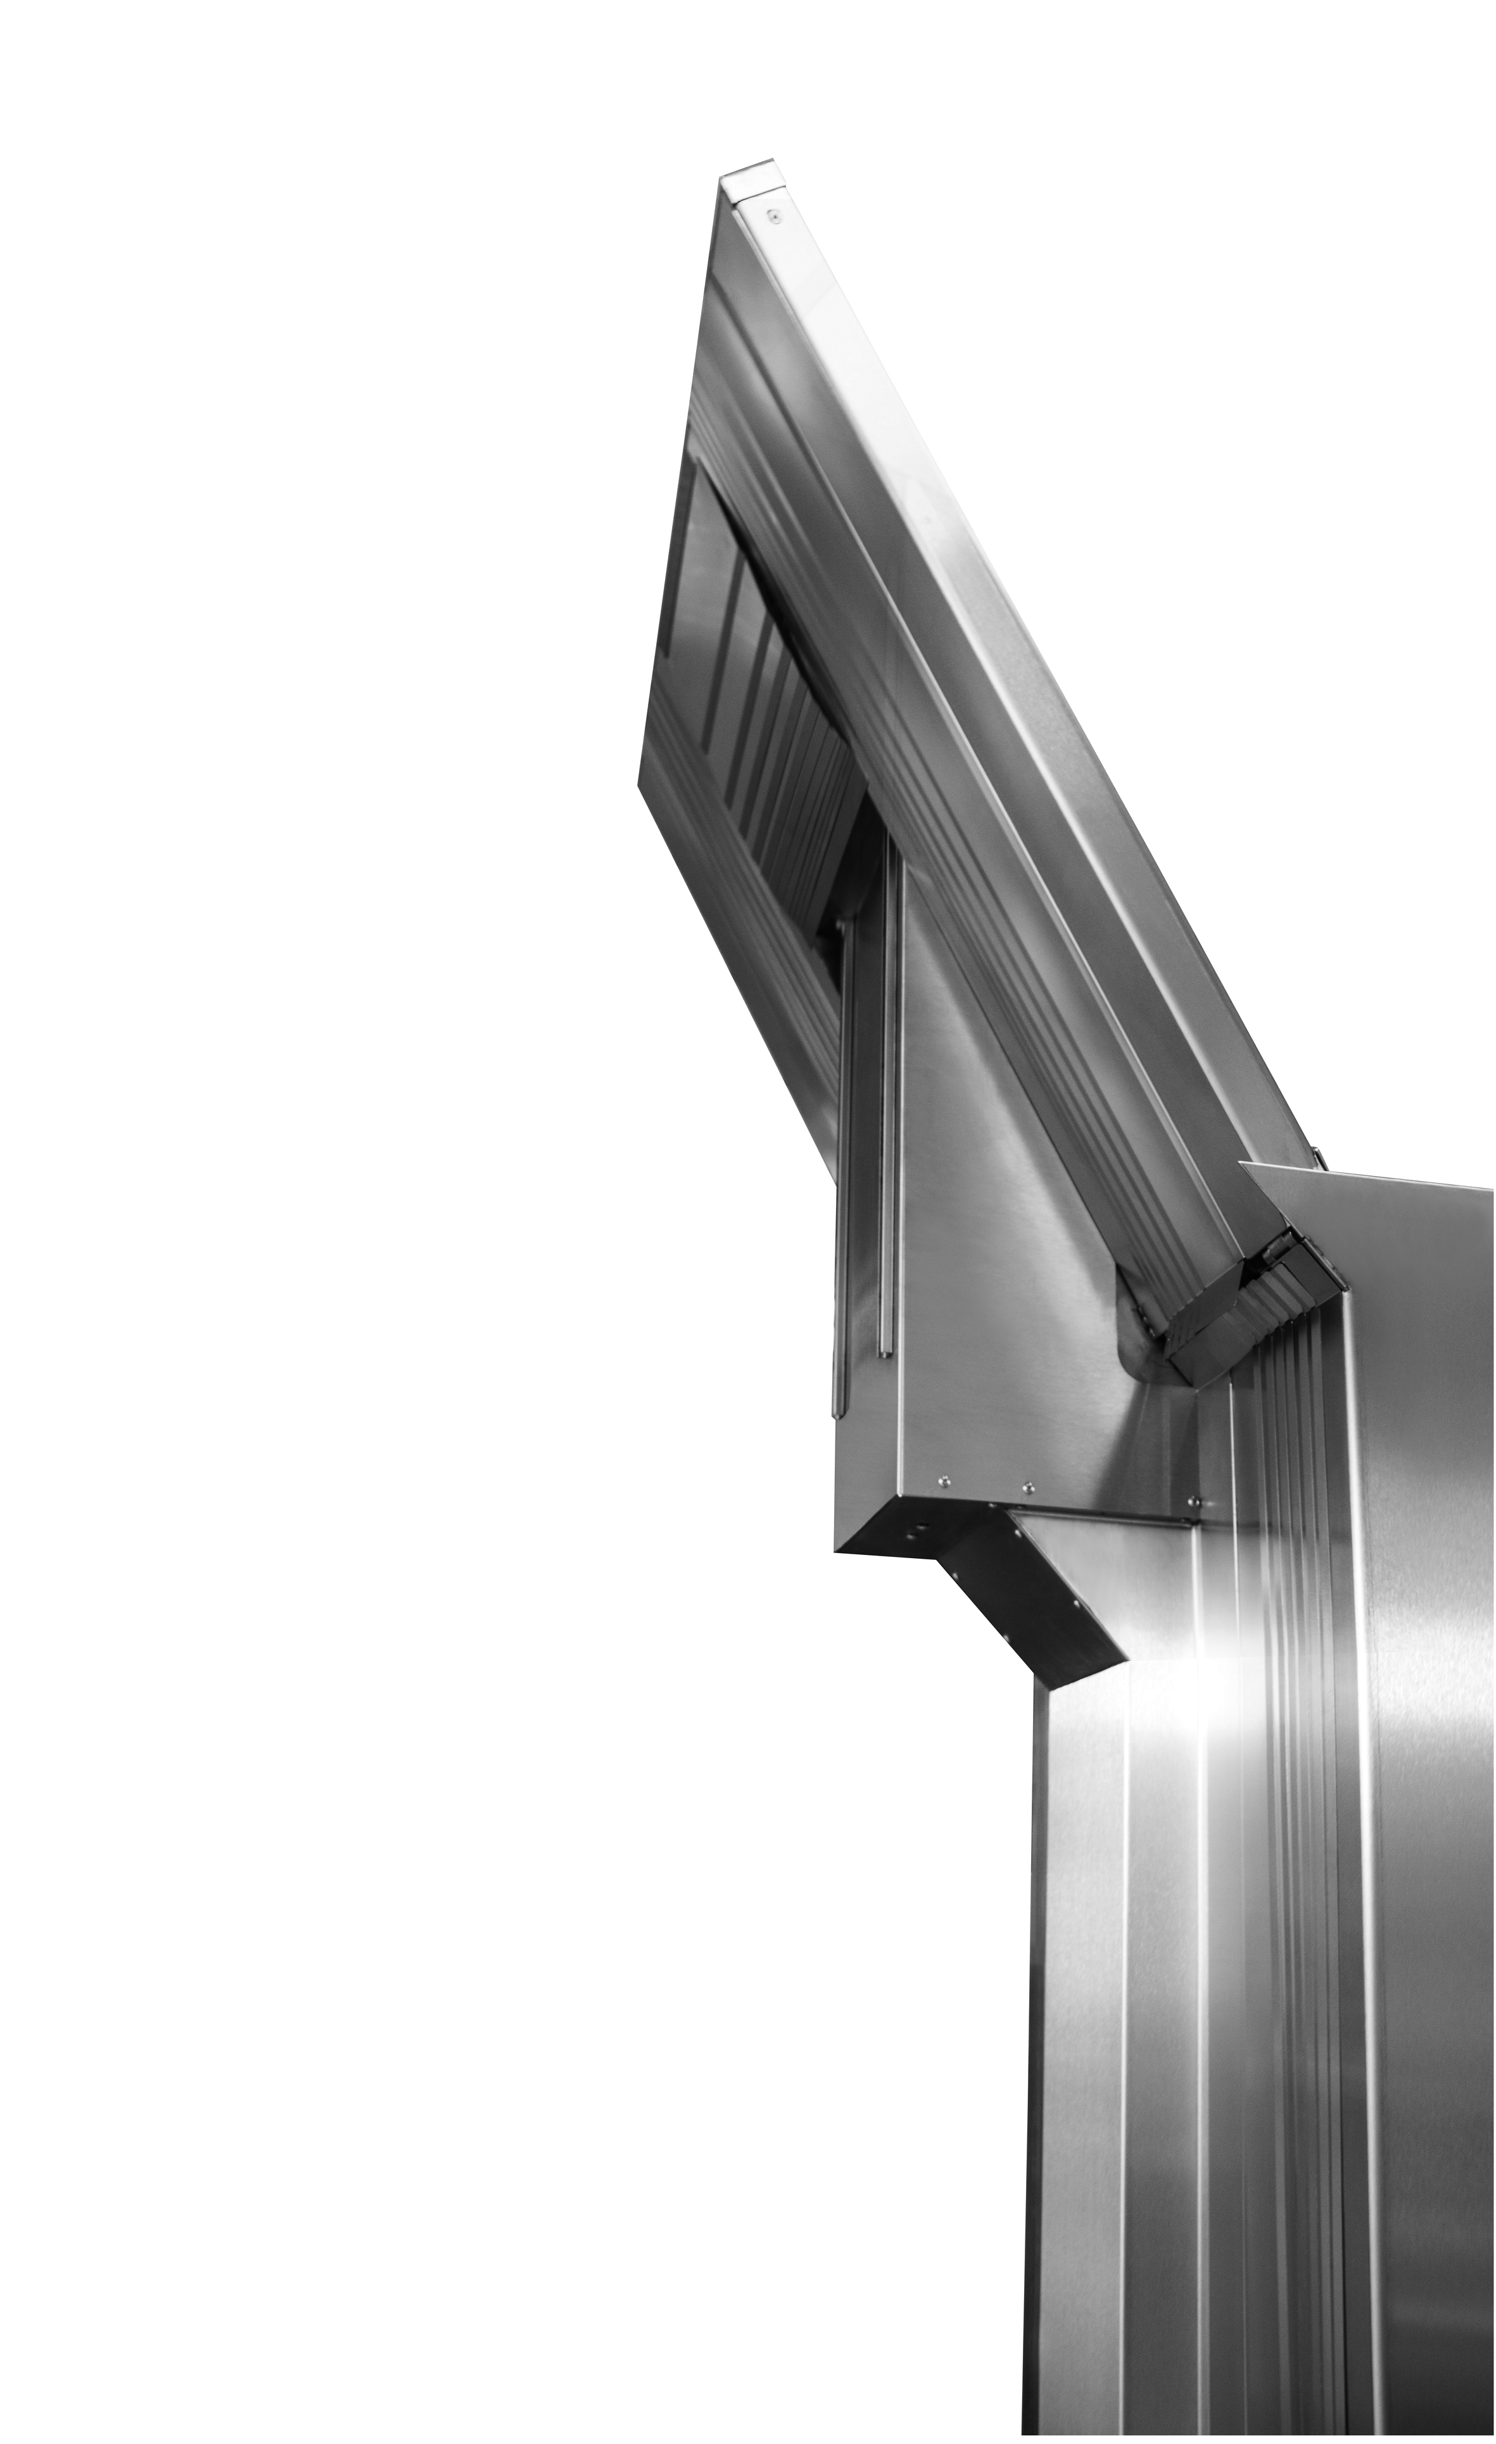

The Moover system also allows the entire roof covering, including the Y-bellows, to be “folded” up and then moved upward manually or automatically.

Picture 3:
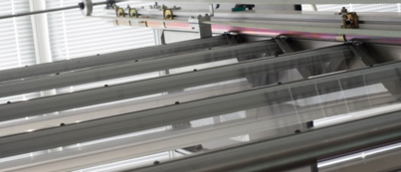
Transparent covering which allows light into the machine processing area.

Arno Arnold GmbH  Bieberer Straße 161  D-63179 Obertshausen | Simone Weinmann-Mang  Tel.: +49(0)6104-4000-0  Fax: +49(0)6104-4000-99  info@arno-arnold.de

